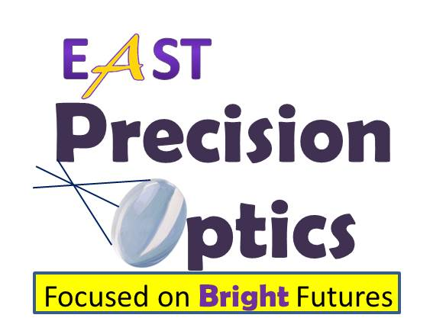**Precision Optics is a +$3 billion a year industry in Monroe County. There are more than 50 businesses and over 3,000 optical design and production jobs in the area.**

The Greater Rochester Area is the United States’ leader in the manufacture and design of precision optics. Optical components made in Monroe County are embedded in medical, military, entertainment, surveillance, and basic research devices.

East’s Precision Optics program exists to interest and prepare high school students to become the next generation of optical technicians, engineers, and scientists. The program’s production facility is equipped with tools, instruments, and machines used in industry. The program’s optics laboratory has lasers, optical components, and metrology equipment on par with upper level college optics courses.

The first year course focuses on optical production. Students learn the basics of drafting, optical machining, metrology, grinding and polishing. Students create lenses and optical flats that go into “East High Optics Kits”. These kits are intended for use in high school physics and science courses that teach an optics unit.

In the second year, the primary focus remains optical production but there is a shift toward design and engineering. While students build up and hone manufacturing skills, they learn fundamental principles of light and geometric optics. Students use computer software to design multi-lens devices (telescopes, range finders, spectrometers, etc.). After design, they fabricate the lenses and then assemble the components into a finished product. Students learn about optical aberrations and use this knowledge to analyze the image quality of their final product.

Students interested in the third course in the program take Geometric Optics. This course has a robust lab component; it is dual-credit with MCC’s first semester optics course, OPT 131.

Our goal is to give students skills and experiences that will prepare them for success in college and in the marketplace. The mission of East’s Precision Optics is *focused on bright futures* for its students.